SPH3U0 ***ELECTROMAGNETISM ACTIVITIES*** DATE:____________

**Learning Goals:** To understand that moving electric charges (electric current) generate an associated magnetic field.

**Activity A:** Materials: Large 6 V battery, copper wire and compass

Connect one end of the wire to one of the battery terminals. Place the compass **below** the wire

and briefly touch the other end of the wire to the other battery terminal. ***This is a short circuit so only keep the wire in contact with the terminal for a few seconds*! O**bserve the response of the compass*. Indicate the direction of the conventional current and the compass direction:*

Repeat this activity with the compass placed above the wire. What do you notice?

**Activity B:**

**Can you visualize the magnetic field around a straight wire**? Briefly connect one or two batteries to the wire device and use a compass to verify there is a magnetic field around the wire. Investigate the field using the compass around the horizontal and vertical portions of the wire.

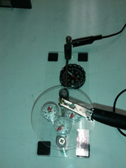

Observations with compass above and below horizontal wire:

Observations with compass beside the vertical wire:

**Activity C:**

**Turn a coil into a magnet!** Briefly connect one or two batteries to a coil and use a compass to verify that it has become magnetized. Try to draw the magnetic field pattern in the space provided. Can you identify the North and South pole?

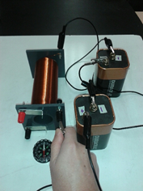

**Magnetic field Pattern:**

**Activity D: Indicate the conventional current direction in the wire. Then indicate the compass needle deflection.**

Direction of compass needle when it is placed below and

above the wire

**Observations for horizontal wire:**

Direction of compass needle when it is placed below and

above the wire

**Switch the battery connections and repeat:**

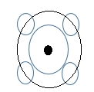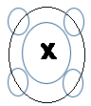**Observations for the vertical wire:** Draw in the compass directions when they are placed around the wire. A DOT means the current is coming up (towards you). A CROSS means the current is going down (away from you).

Discussion: Did the observations match the RHR #1 predictions?

**Activity E: Magnetic Field around a Current-Carrying Coil (Solenoid)**

**Observations: Observations:**.

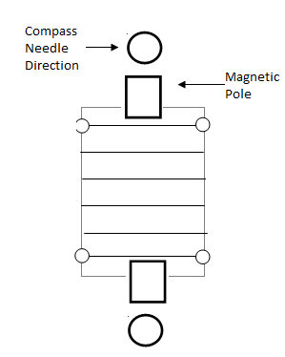 Indicate the current and compass directions. Switch the battery connections & repeat

Discussion: Do your observations match the RHR #2 predictions?